New Specifications for Vacation Management Feature
Leave Management Manual
Table of Contents

1. Introduction 1
1.1. Differences in How Leaves are Taken 1
2. Prepare for Schedule management 2
2.1. Leave Type Settings 2
2.1.1. Setting instructions 3
3. To Take Full or Half-day Leave 5
3.1. Full Day Leave Pattern Settings 5
4. To take hourly leave 6
4.1. The Pattern Method 6
4.2. The Leave Type Method 6
5. To Edit Attendance Data 7
5.1. To edit attendance data 7
5.1.1. Descriptions 7
6. To Plan Schedules 10
6.1.1. Set schedules to each employee 10
7. To Manage Schedules 11
7.1. Take leaves 12
7.1.1. Take Full Day or Half Day Leave (Pattern Method) 12
7.1.2. To Take Full Day or Half Day Leave (Leave Type Method) 13

Introduction
There are two types of leave request methods: "Pattern" and "Leave Type".
The "Administrator's Manual" provides information on how to set up and take leave using the "Leave Type" method.
This manual contains excerpts for customers using the "Pattern" method, which differs from the "Leave Type" method.

Differences in How Leaves are Taken
The following are the differences on how leave is taken in the admin's schedule management screen and the employee's schedule request screen.

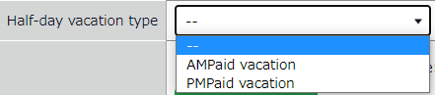
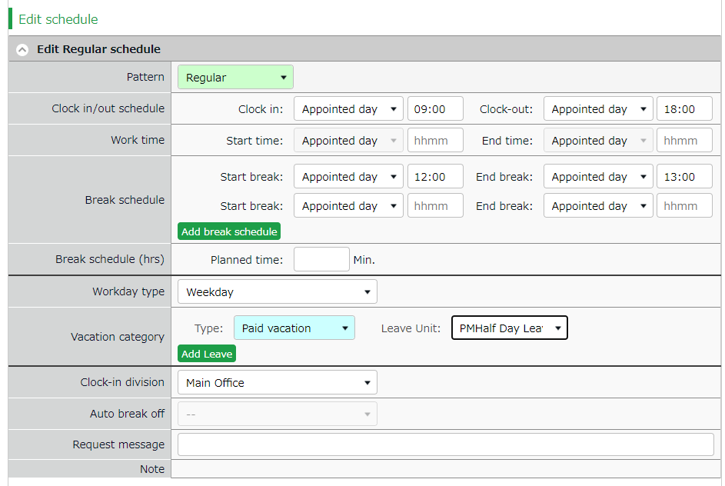
The Pattern Method
The Leave Type Method

Please refer to the following for details.
- To take hourly leaves（p.6）
- To take full or half day leaves（p.13）

Prepare for Schedule management
This section describes the settings related to Schedule management, such as work hours and leaves.

Leave Type Settings
Settings > Schedule > Pattern settings
When you create a leave type, a leave tally column is displayed on the time card.
When using patterns, the leave type is linked to the full-day leave pattern becomes available as an option on the schedule management screen or the schedule request screen. You can also directly apply the leave type to the schedule. By applying a full-day leave pattern or a specified leave type to a schedule, the system will handle that day as a day off and the number of leaves will be recorded in the leave tally column.

The number of full day leave patterns or leave types set to the schedule are counted as the number of leave taken.
Leave type

Time Card screen

To take leave, set a full day leave to the schedule.
Full-day leave pattern

Setting instructions
This section describes the Leave Type settings under [Settings > Schedule].

Click [New Registration] or [Edit] to go to the registration screen.
Enter required info then click [Save].
The setting items are described below.

Name | Enter the name of the leave. (Examples: Paid leave, Compensatory leave, Special leave, etc.)
Half-day leave | By selecting [Apply], users can take half-day leave.
Calculating obtained leaves | Choose either of the following to specify the leave calculation method.  Subtract (Subtraction)  Manages the number of granted leaves, leaves taken (used), and remaining leaves.  Generally used for managing paid leaves.  Add (Addition)  This setting can be used for managing leaves that only needs monitoring of the numbers taken.  This is generally used for managing absences and legal holidays.
Increase/Decrease of Leaves when Working days on holiday is taken | * Only shows in [Compensatory leave].  If you select [Increase by time-off clock-in], compensatory leaves are granted automatically, if working hours during [Legal or Non-legal time off] exceed specified hours.
Grant substitute time-off | Perform settings here to use this leave type as compensatory leave.  If you select [Grant substitute time-off for substitute clock-in schedule], the [Substitute clock-in] (compensatory work day) item is available in the Add schedule screen. Compensatory leaves are granted automatically when working hours in [Substitute clock-in] exceed specified hours.
Allow negative number | This keeps employees from taking leaves when there are none left.  * Only available if [Calculation method of leaves when obtained] is set to [Subtract].
Valid period | Leaves are available from its grant date until the period specified in this setting. You cannot take leaves after this period. You cannot leave this field blank.
Leave Expiry Period | By checking the checkbox, you can edit the expiration period if the leave type has an expiration period.
Leave by hours | By selecting [Apply], users can take hourly leaves.  You can take Hourly leaves from the f[Subtraction] type leaves as well (maximum of 1 to 5 day’s leave). This setting can limit the amount of hourly leaves that employees can take within a year.  Daily contract work hours less than 1 hour  Under Japan’s Labor Standards Act, annual paid leave must be rounded up if there are a fraction of contract working hours for less than one hour. However, for holidays other than paid leave, you can choose between “Round up” or “Do not round up”.
Full day leave Type Count（*） | By checking the checkbox, the [All-day vacation (Half day)] option become available. Use this option to take a full day leave in place of the originally planned half-day work.
Display leave Type Color（*） | Specify the color of the leave type on Time Cards and Schedule Management screens.
Image upload for Leave Request | Employees can attach doctor’s note when requesting sick leaves. You can select [Required], [Optional] or [Not Required] for each leave types.
Override Workday Type if schedule is set to Full-day Leave（*） | You can specify the weekday type of the leave day.
Leave Type-only Schedule Request（*） | This setting determines whether employes take leaves by choosing a leave category alone or require pairing it with a work schedule.  The system cannot calculate deemed working hours during paid leave, if no work schedule (Clock in - clock out time) is set.
Calculate Discretionary Holiday Work Hours（*） | Required for calculating deemed working hours during paid leave.

*This item is displayed if you are using the “Leave Type” leave management method.

To Take Full or Half-day Leave

Full Day Leave Pattern Settings
Settings > Schedule > Pattern settings
If your are using the Pattern Method, first create a schedule pattern for taking leave. If you are using the Leave Type Method, employees can select leave types directly on the Schedule Requests instead of using a leave pattern. Each method has a different way of taking hourly leaves. Please refer to p. 6 for details.

Schedule Request Screen (Pattern Method)

To take a leave, set a full day leave pattern to the schedule.
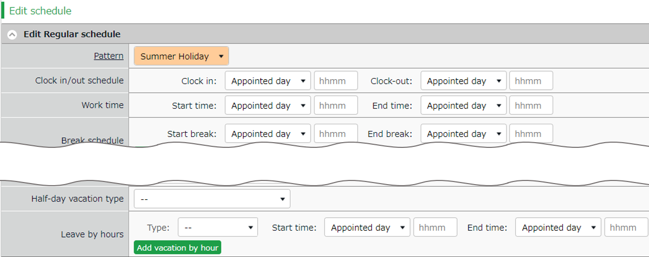

To take a half-day leave, select either [AM] or [PM].
Half-day vacation type

To take hourly leave, select the leave type at the [Type] dropdown box.
Leave by hours
Pattern

Schedule Request Screen (Leave Type Method)
To submit a leave request, select the type and the unit of the leave (All-day, AM or PM leave, hourly leave).
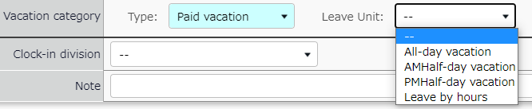
Leave type
■■■不要
Select a leave type at [Type] then select a leave unit.

To take hourly leave
In the old version, employees are required to enter the start time, then specify the number of hours (Obtained hours) when taking hourly leaves. In the new version, employees are required to enter the end time instead of the number of hours.

Hourly leaves request items:
- The old version: [Start time] and [Obtained hours]
- The new version: [Start time] and [End time]

The new version has two display options when taking leaves: “The Pattern Method”and the “The Leave Type Method”.
Here are the differences employees would see when they are requesting hourly leaves.

The Pattern Method
Items are shown in the [Leave by hours] category.
Employees are required to enter [Start time] and [End time].

The Leave Type Method
Items are shown in the [Leave by hours] category.
Employees need to select the unit, then enter [Start time] and [End time].

Please refer to p.13 for details on half day leave.

To Edit Attendance Data
You can correct errors caused by missing time records and schedule errors.

To edit attendance data
This section describes the Time record and Schedule screens in edit mode.

[Where to look] All menu > Attendance data > Daily data > [Edit] button
* The Time Card button is also available in the Time Card screen.

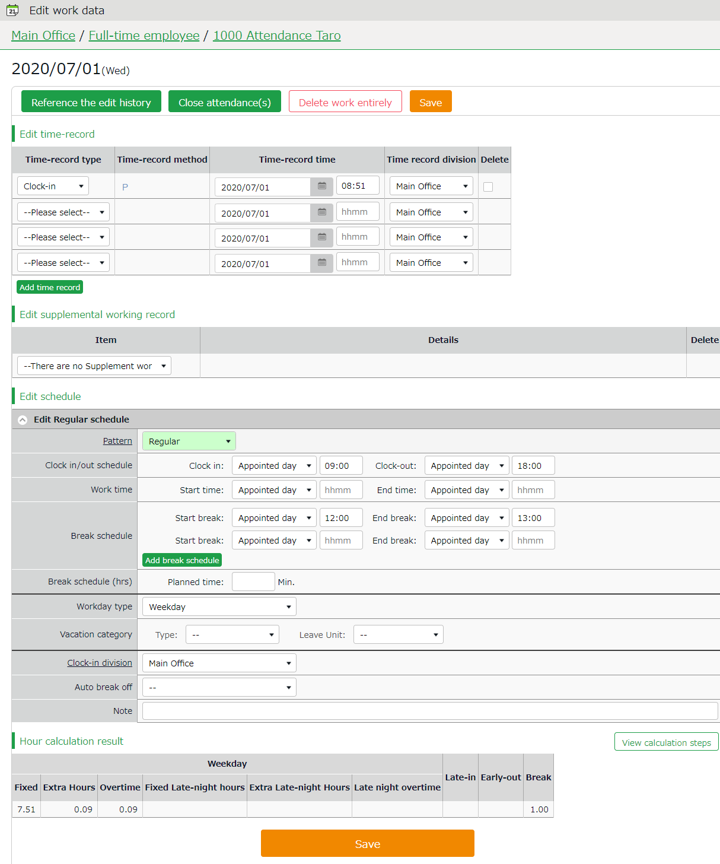
Descriptions
Edit schedule

Edits time record data.
Edit time record

Edit time record data.
Save

Saves changes.

Shows daily summary.
Press the [View calculation steps] button to confirm the calculation process.

Hour calculation result

Edit schedule
If you select a [Pattern], the scheduled time in Pattern settings are applied.
You can enter items directly as well.
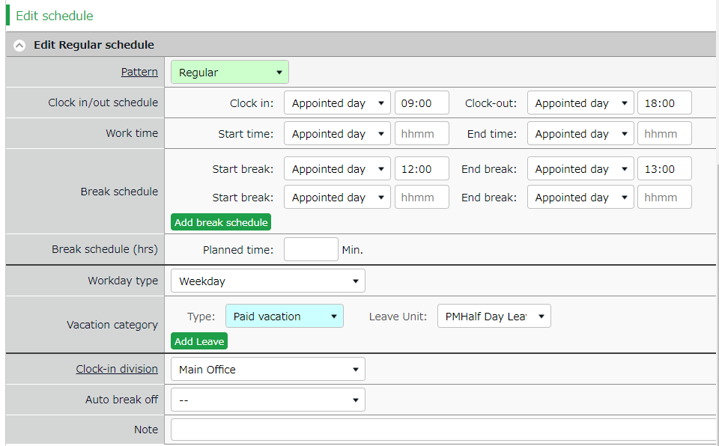

Patterns | Select a pattern. You can create patterns at [Pattern settings].
Clock-in/out schedule | Set a clock-out schedule.
Work time | Specifies the time to run attendance calculations.  Any work before scheduled clock-in time and after clock-out time will not be included in the calculation.
Break schedule | The time between [Start break] and [End break] are regarded as break time.
Break schedule (hrs) | Calculates the entered amount of time as break time.  You cannot specify a time slot for break time.
Workday type | Determines whether the work took place during holiday or not. If none is specified, workday type is set to [Weekday].  If you choose [Non-legal time off] or [Legal time off], work time during that day will be added up to [Legal time-off work days], [Assigned time-off (hrs)], [Unassigned time-off (hrs)], [Assigned Late-night hours on holiday], and [Unassigned Late-night hours on holiday].
Leave type | Select the leave type and the unit (such as All-day, AM leave, PM leave and Leave by hours) here.
Leave by hours | If your company uses the ‘Pattern Method', this item appears in place of 'Vacation category'. Select the type of leave, start and end time.
Clock-in division | Shows where the employee clocked in.  The system automatically applies the name of the division time recorder last used.
Auto break off | This will disable the Auto-break feature and break time setting by schedule.
Note | Enter comments or notes in 250 characters or less if needed.

To Plan Schedules

This section describes the steps to create a work shift table by divisions.

- Go to the Schedule management screen, then select one division.
Press the [Add schedule] button displayed on the screen.

The schedule set to [Original schedule] applies to the checked day's attendance data.
Repeat this step to complete the month’s work shift table.
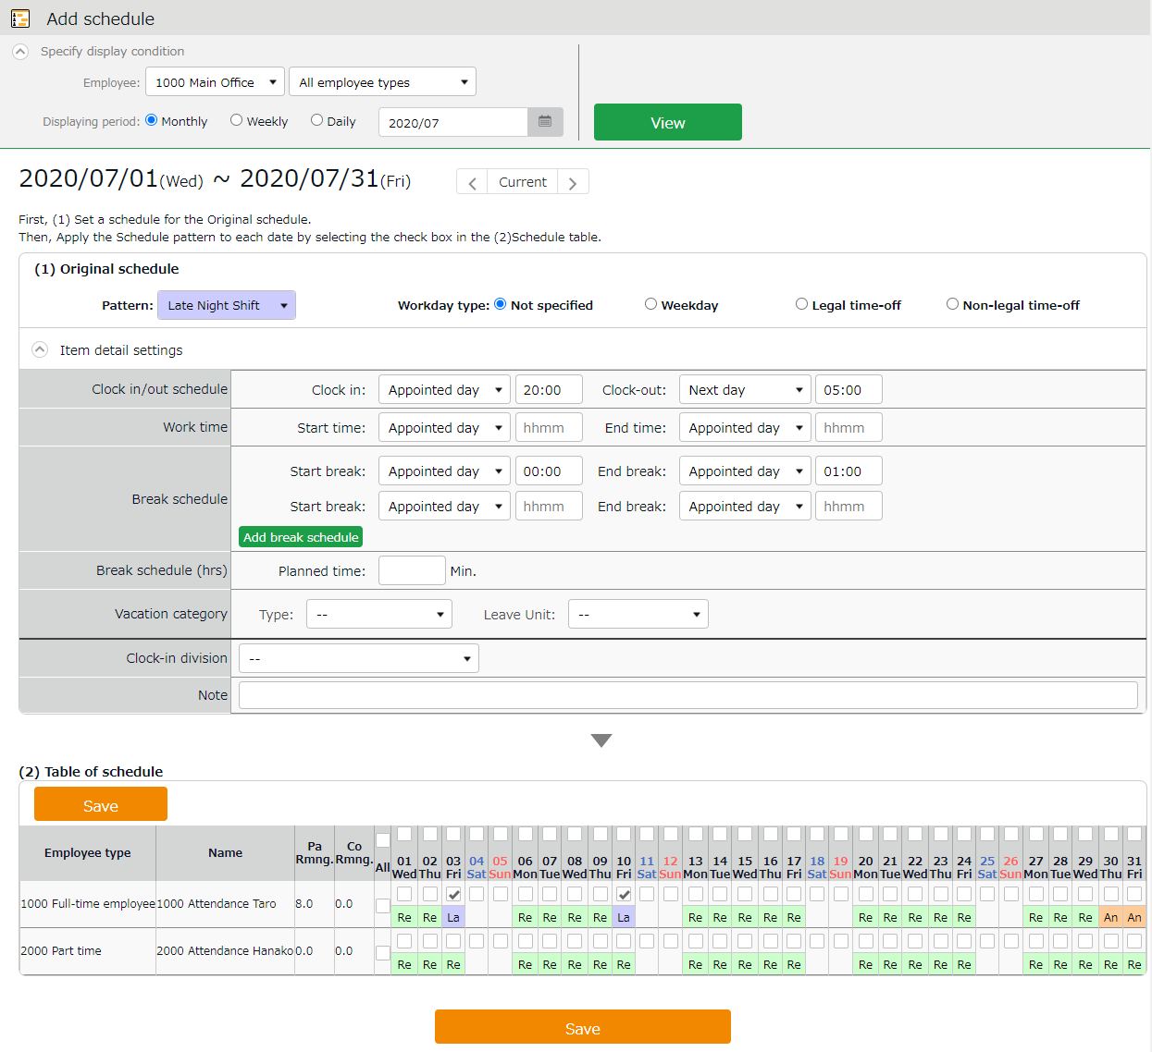

Enter schedule. To apply pre-configured time schedule, select a pattern.
You can also enter the items manually by clicking [Item detail settings].
Original schedule

Apply

The list of employees and applying dates are shown.
By turning the check on, the schedules set above applies to the selected day.
If you check [All], the schedule settings are applied to all employees and dates below.

Target

- Click [Save] to save the schedules.

Set schedules to each employee
This section describes the steps to set schedules for each employee.

- Press the [Edit] button in the Schedule management screen.
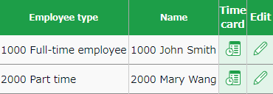

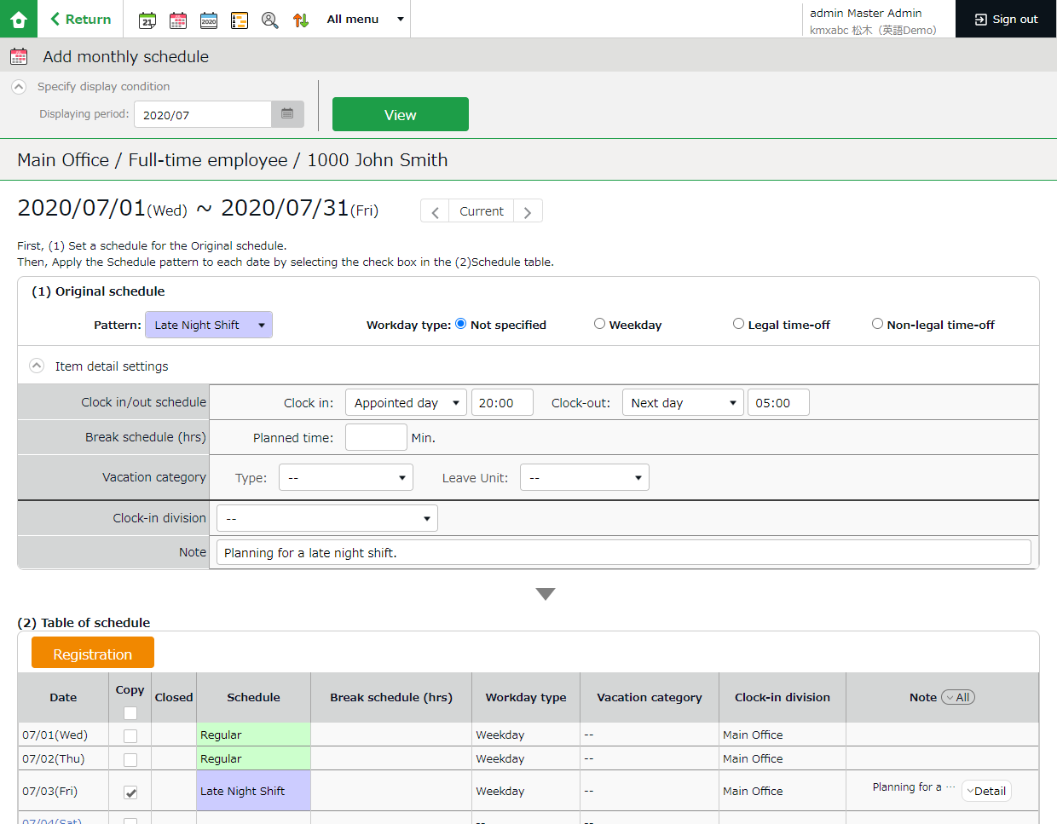
The Monthly schedule screen is shown. The schedule set to [Original schedule] is applied to the checked day's attendance data.

Enter schedule. To apply pre-configured time schedule, select a pattern.
You can also enter the items manually by clicking [Item detail settings].
Original schedule

Click [Detail] to open the [Note] text field.
Note

Apply

The list of applying dates are shown.
By putting a check, the schedules set above are applied to the selected day.
Target

- Click [Save] to save the schedules.

To Manage Schedules
This section describes the Leave management feature.

Take leaves
Plan leaves at the Schedule Management screen by selecting a leave pattern or a leave type under the desirable date.

[Where to look] All menu > Schedule > Schedule management

Take Full Day or Half Day Leave (Pattern Method)

Take full-day leave
Select a leave pattern under [Original schedule].

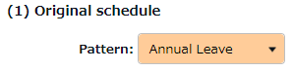

Take half-day leave
- To take a half-day leave, click [Item detail settings].
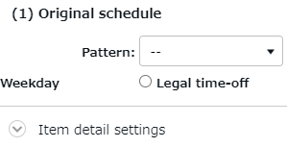

- Select [AM leave] or [PM leave] at Half-day vacation type.
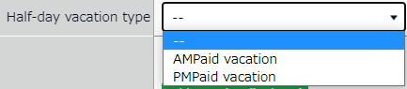

To Take Full Day or Half Day Leave (Leave Type Method)

Take Full-day Leave
If you have created a leave pattern, you can select a full-day leave pattern (Paid Leaves and Comp Leaves) at the [Pattern] column under [Item detail settings], then select [All-day vacation] at Leave Unit.

Take Half-day Leave
To set a half-day leave, select [AM leave] or [PM leave] at Leave Unit.

The name of the half-day leave will be shown in the corresponding day’s schedule.
If you check the summary of leaves taken, you can see that half-day leaves count as 0.5 days.

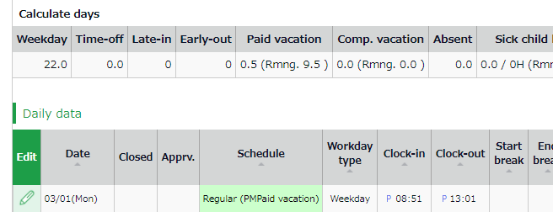
If you are using the new version of Leave Management, future leaves are counted.

Unauthorized copying and replication of the contents of this guide, text and images are strictly prohibited.
The contents of this guide are subject to change without prior notice, for revision and further improvement.

Last Updated - March 15, 2021

