Employee Manual
Table of Contents
1. What can I do on KING OF TIME? 3
1.1. Use the Time Recorder 3
1.2. Check your attendance data 3
1.3. Submit requests 3
2. Using Time Card on PC 4
2.1. Supported browsers 4
2.2. Log into Time Card 4
2.3. All menu 5
2.4. Check the Time Card 6
2.4.1. Description 6
2.4.2. Operation 8
2.5. Edit time record data 9
2.5.1. Description 9
2.5.2. Submit request 10
2.6. Edit Supplemental Item 11
2.6.1. Description 11
2.6.2. To Submit Request 12
2.7. Edit schedules/Take leaves (multiple requests at once) 13
2.7.1. Description 14
2.7.2. To Submit Request 15
2.8. Edit schedule and take leave (Detailed request) 16
2.8.1. Description 17
2.8.2. To Submit Request 18
2.9. To submit overtime requests 19
2.9.1. Description 19
2.9.2. To Submit Request 20
2.10. Check for schedule patterns that I can use 21
2.11. Confirm request log / Cancel requests 21
2.12. Change password 22
2.12.1. To change password 22
3. Using Time Card on Mobile Browser 23
3.1. Supported browsers 23
3.2. Log into Time Card 23
3.3. All menu 24
3.4. Confirm Time Record/Supplemental Items 25
3.5. Confirm schedule 26
3.6. Submit Various Requests 27
3.6.1. Schedule Request 27
3.6.2. Time record request 28
3.6.3. Overtime Request 29
3.6.4. Submit Supplemental Item Info 30
3.6.5. Confirm attendance data 31
3.6.6. Confirm or cancel request 32
4. My Recorder 33
4.1. My Recorder 33
4.2. Supported devices and browsers 33
4.3. To access My Recorder 34
4.4. Operate My Recorder 35
4.4.1. Clock-in/out 36
4.4.2. Check Time record history 36
4.4.3. Display Time Card 37
5. Mobile browser recorder 38
5.1. What is a Mobile browser recorder? 38
5.2. Supported models and mobile carriers 38
5.3. To access Mobile browser recorder 39
5.3.1. Check Email settings 39
5.3.2. To access 40
5.4. Operating the Mobile browser recorder 41
5.4.1. Clock-in/out 42
5.4.2. Check attendance status 42
5.4.3. To Check Time Card 42
6. FAQ 43
6.1. I forgot my login info. 43
6.2. I submitted the wrong request. 43
6.3. I somehow got logged out when I accessed the My Recorder URL. What happened? 43
6.4. [Admin] How do I send My Recorder URL? 43

What can I do on KING OF TIME?
KING OF TIME is an attendance management system.
You can keep attendance record, manage shifts and leaves.

Use the Time Recorder
In the Time Recorder screen, you can record clock-ins/outs, start/end of breaks.
Please refer to the [Time Recorder manual] for information on Time Recorder.
This manual describes 2 methods to operate Personal Time Recorder.

My Recorder
For smart phones and PC browsers - p.33

Mobile browser recorder
For mobile phones and smart phones - p.38

Check your attendance data
You can check your attendances and working hours by logging into
[Time Card], with PC or mobile phone.

Please refer to the following pages for instructions on Time Card.

Submit requests
You can submit schedule change requests by logging into [Time Card], with PC or mobile phone. Requests are reflected on Actual work data upon your administrator’s approval.
Please refer to the following pages for instructions on Time Card.
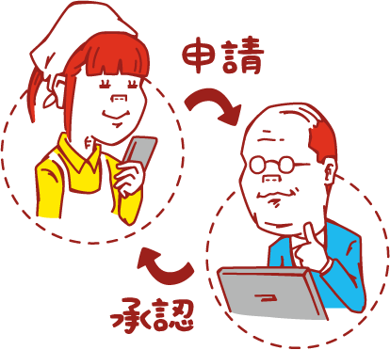

What is Time Record Request?
This is a request to make changes to time record data
(clock-in/out time). Employees usually submit time record requests
when they forgot to clock-in/out or have clocked-in/out by mistake.

What is Schedule request?
This is a request to edit schedules. You can take leaves from Schedule Request as well. Submit Schedule requests to change shifts or to take leaves.

Using Time Card on PC
You can review your attendance data, submit requests and change your password from Time Card. This section describes how to use it on a PC browser.

Supported browsers
The following browsers support Time Card.
Please use the latest version.

Google Chrome | Microsoft Edge
Windows
Mac

Log into Time Card
There are 2 ways to access the Time Card screen; by entering your ID, and by using the Time Recorder.

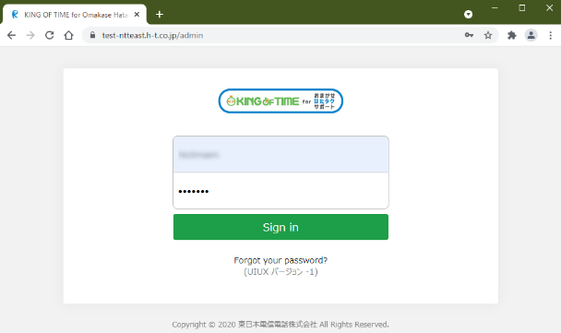
Log in with ID
Start your browser and enter the Login URL. Enter your login ID and Password, then click [Login].
* Please use the login URL and ID issued by your administrator. Please be sure to set your password.

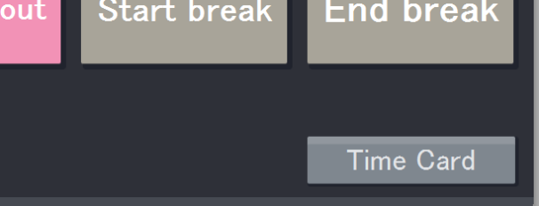
Log in from Time Recorder
To access the Time Card screen, press the [Time Card] button on the Time Recorder and authenticate by fingerprint, IC card or password.
* Time Recorder design may vary by authentication type.

All menu
After login, select an item on All menu, in the top left of the screen.

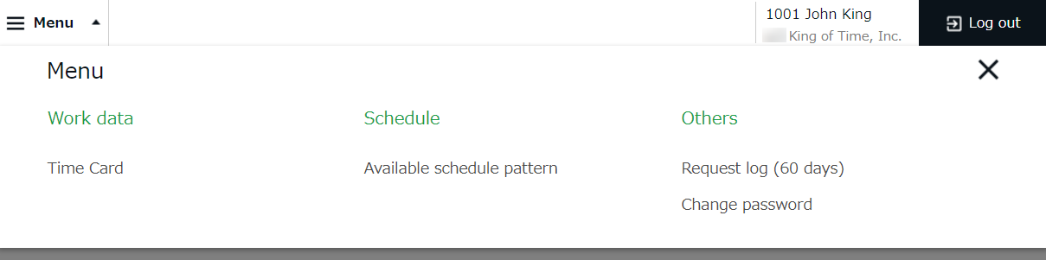

The following are available on Menu.

Time Card | Check your attendance data.  Submit time record edit requests and Schedule requests from here. | p.6
Available schedule patterns | Check the schedule patterns available to you. | p.21
Request log (60 days) | Shows the requests that you have submitted in the past 60 days.  You can cancel requests from here. | p.21
Change password | Change your password from here. | p.22

Check the Time Card
Check your time record, attendance data and reports in real time.
Time record edit requests and Schedule requests can be submitted from here as well.

All menu > Attendance data > Time Card

2.4.1. Description

Select a month. Click [Show] to view data.
Options
Gather time-record: Arrange time record data to a single cell.
Weekly summary: Displays overtime hours after applying statutory working hours per week.
Display by employee work location: Displays location information recorded when clocking in/out.
Classify holidays as Legal and Non-legal holidays: You can check holiday work hours according to workday type.

Specify the display condition

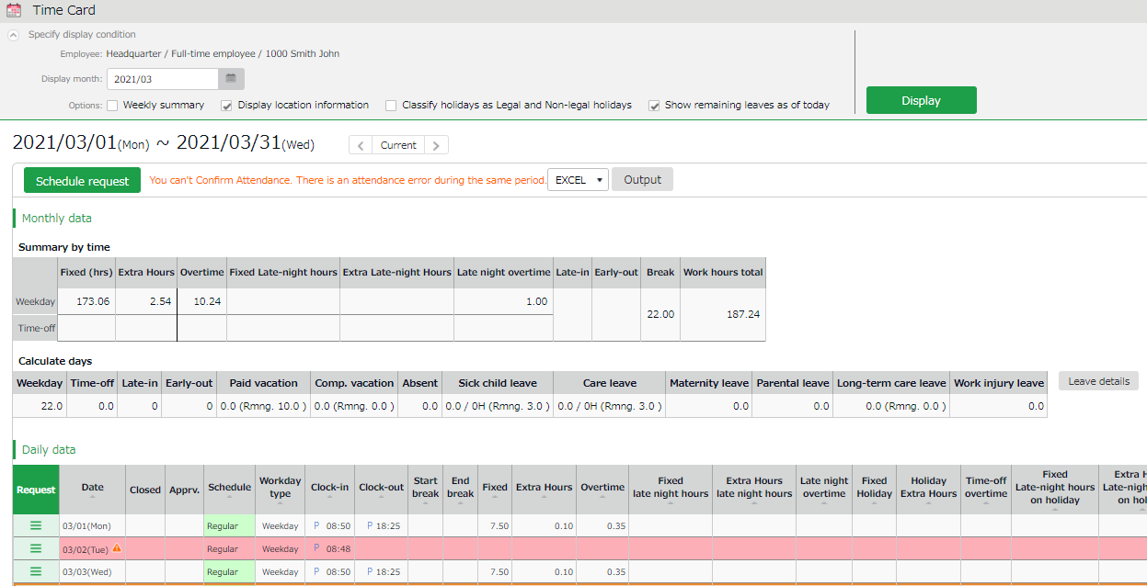

Shows calculated data, such as the number of working days/hours and leaves taken.
Monthly data
Daily data

Check time record, schedule and attendance calculations.

Check Daily data

Light red indicates Attendance error. To run calculations correctly, you need to fix the errors.
Attendance data error

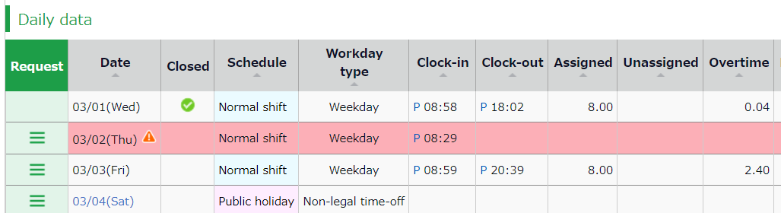

Click [ Ξ ] to open the Request menu.
Click [ Ξ ] at Request
Click

 | This mark is shown next to dates with Attendance error, which is also highlighted in light red. It will be hidden once the error is resolved.
Cl.(Close) | You can check closing status.  The check mark () indicates that the attendance is settled (closed) by your administrator. You cannot submit Time record edits and Schedule requests.
Schedule | Shows schedules and leaves.  If an Admin creates and applies a Pattern to the schedule, the name of the pattern shows on the grid. [Shift] indicates a schedule that does not belong to any pattern.
Workday type | Either of the 3 types are applied: [Weekday], [Legal time off], and [Non-legal time off].
Clock-in/out | Clock-in/out time and method are shown. Examples:  P - Password, IC - Card reader, HB - Finger hybrid scanner,  Edit - Time record has been edited,  Approve - Changes to time record approved
Note | Comments from your administrator are shown. The administrator can choose whether to reflect your Request message to the Note field when processing the request.

2.4.2. Operation
You can Perform the following tasks in Time Card.
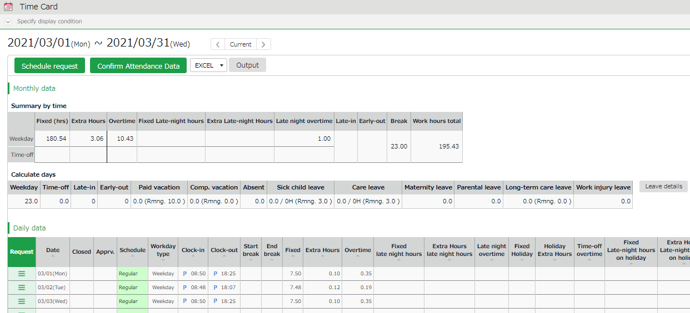

3
2
1ｚ

4

5

No.  1ｚ | Buttons | Description
1 | 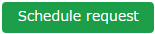 | Submit a month’s worth of schedule or leave requests at one time (p.13).
2 | 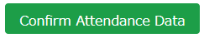 | Mark your attendance data for the displayed month as confirmed.  The button is displayed when there are no attendance errors or unapproved requests.
3 | 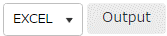 | You can download Time Card data in Excel format.
4 |  | Check the leaves taken/remaining.
5 | 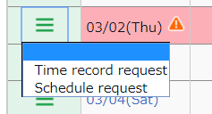 | Submit request to edit time record (p.9).
 |  | Submit Supplemental item info (p.11).
 |  | Submit schedule or leave request by day (p.16).
 |  | Submit overtime request (p.19).

The items shown in the screen may vary by settings.

Edit time record data
You can submit time record requests if you forgot to clock-in/out.
Go to the Time Card screen and click [ Ξ ] in the Request column of the corresponding date. Then click [Time record request].
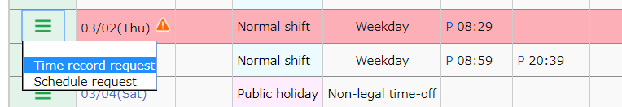

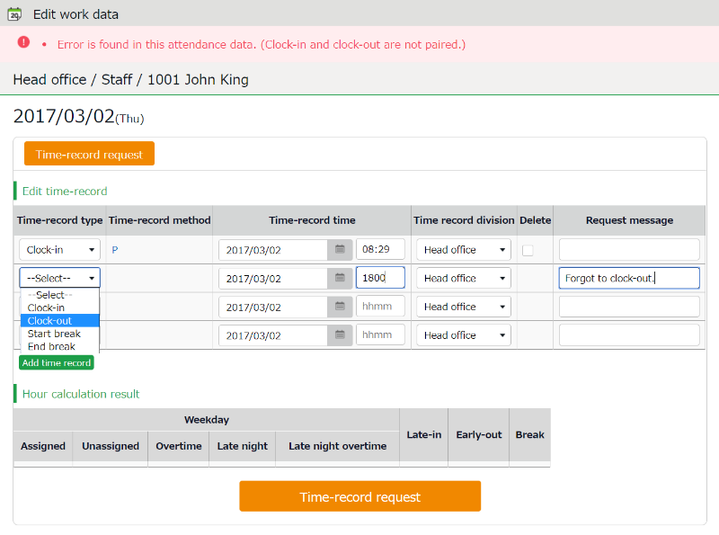
2.5.1. Description
Time record request
Time record request

Submit change request from here.

Edit time record data.

Time-record type | Select a time record type such as Clock-in, Clock-out, Start break and End break.
Time record method | Time-record method is displayed automatically.
Time-record time | Enter clock in/out time.
Time record division | Select another division if you are clocking-in to another division as a guest.  Unless specified, your own division is set to default.
Delete | Turn the check box on to submit deletion request.
Request message | Enter the reason of request.  Your administrator will read this message when checking your request.
Add time record | Click here to add new fields.

2.5.2. Submit request
Enter the items required and press [Time record request].

Delete time record
For example, delete time record data if you clocked in/out by mistake.
Put a check in the [Delete] column and enter [Request message].

Edit time record
For example, edit time record data if you selected the wrong Time record type (e.g. selected “Clock-in” when requesting changes to clock-out record by mistake).
Correct the existing data and enter [Request message].

Add time record
For example, you can add time record data if you have forgotten to clocked-in/out.
Enter the Time record type (clock-in/out) and time in the new row.
Enter [Request message] and submit.

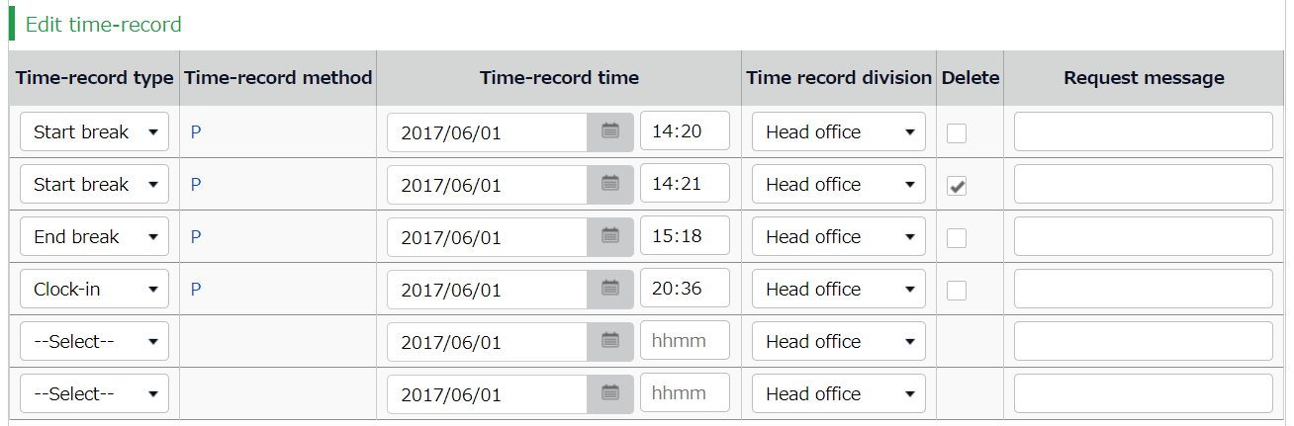
3
2ｚ
1ｚ

Edit Supplemental Item
Supplemental Items can be used to submit attendance related requests other than clock in/out data. These items are created by your admin.
Go to the Time Card screen and click [ Ξ ] in the Request column of the corresponding date. Then click [Suppl. items request].
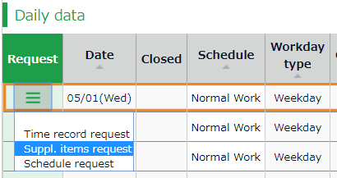

2.6.1. Description
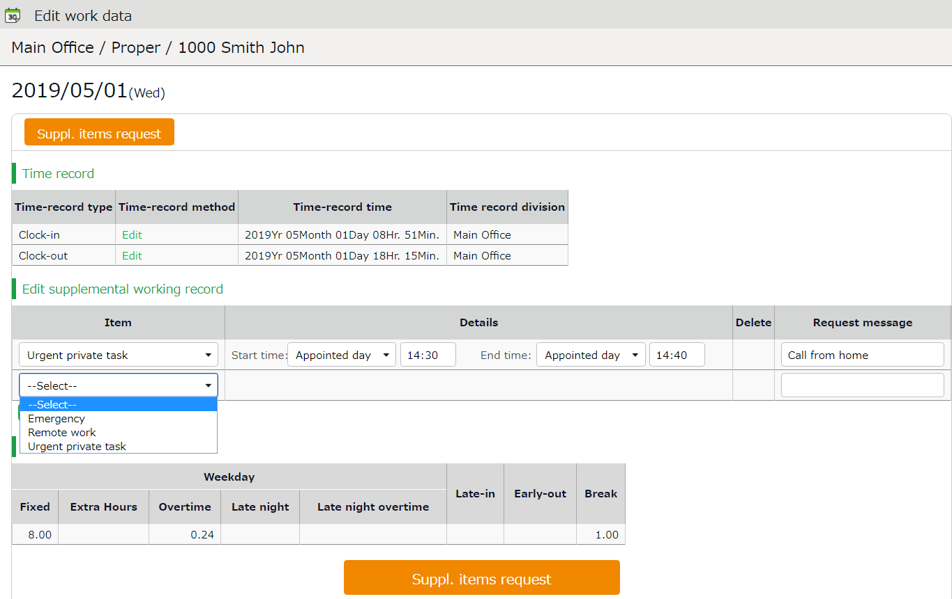

Submit change request from here.
Submit Supplemental items request

Enter the details of request.
Item | Select an item.
Details | Enter details accordingly.
Delete | Turn the check box on to submit deletion request for existing content.
Request message | Enter the reason of request.  Your administrator will read this message when checking your request.
Add record | Click here to add new fields.

Suppl. items request

Submit the request.

2.6.2. To Submit Request
Enter required info, then press the [Request] button.

To add Supplemental Item
Enter the items, content, or message, then click the [Request] button.
To submit request for more than one data item per day, click the [Add record] button to add a new row.

To edit Supplemental Item
If you need to change an existing supplemental item, edit the data as needed, then enter the Request message and click the [Request] button.

3. To delete item
Delete the entire row as follows.
Turn the check on the [Delete] column and enter [Request message] before submitting.

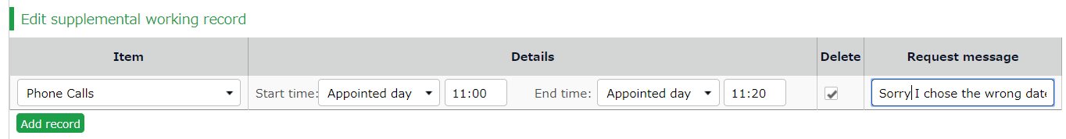

Edit schedules/Take leaves (multiple requests at once)
This section describes the steps to submit a month’s worth of requests at once. Click [Schedule request] in the Time Card screen.

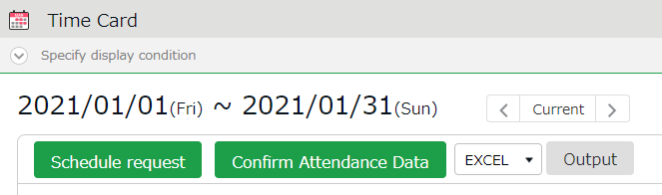

2.7.1. Description

Submit change request from here.
Request
Schedule request
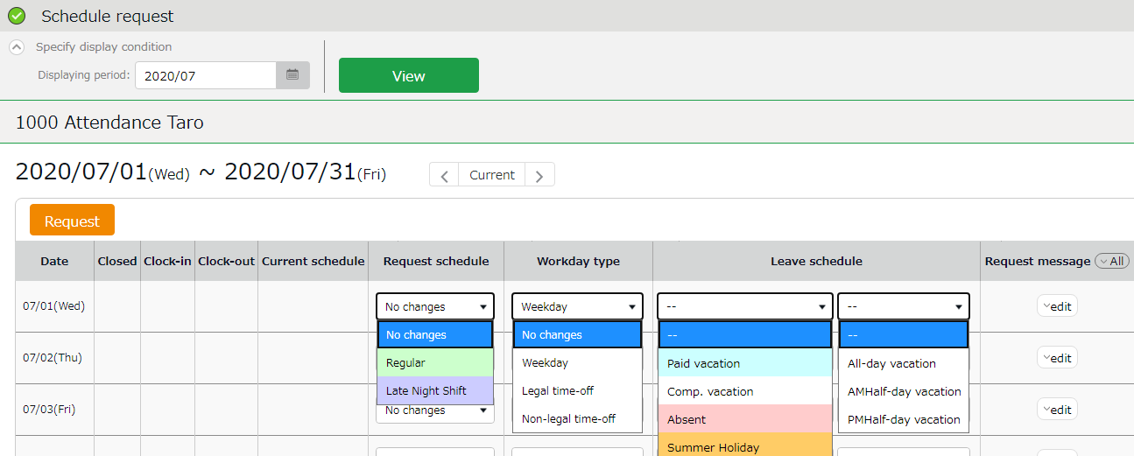

Enter the details of request.

Clock-in/out | Time record are displayed.
Current schedule | Existing schedules are shown.
Request schedule | Set a schedule pattern for intended day.
Workday type | You can choose from 3 types: [Weekday], [Legal time off], and [Non-legal time off].  If none is specified, this is set to [No changes].
Leave schedule | Take full day or half-day leaves (AM or PM leave) from here.
Request message | Enter the reason of request. Click [Edit] to enter Request message. Your administrator will read this message when processing your request.

2.7.2. To Submit Request
Enter the items required, then press the [Request] button.
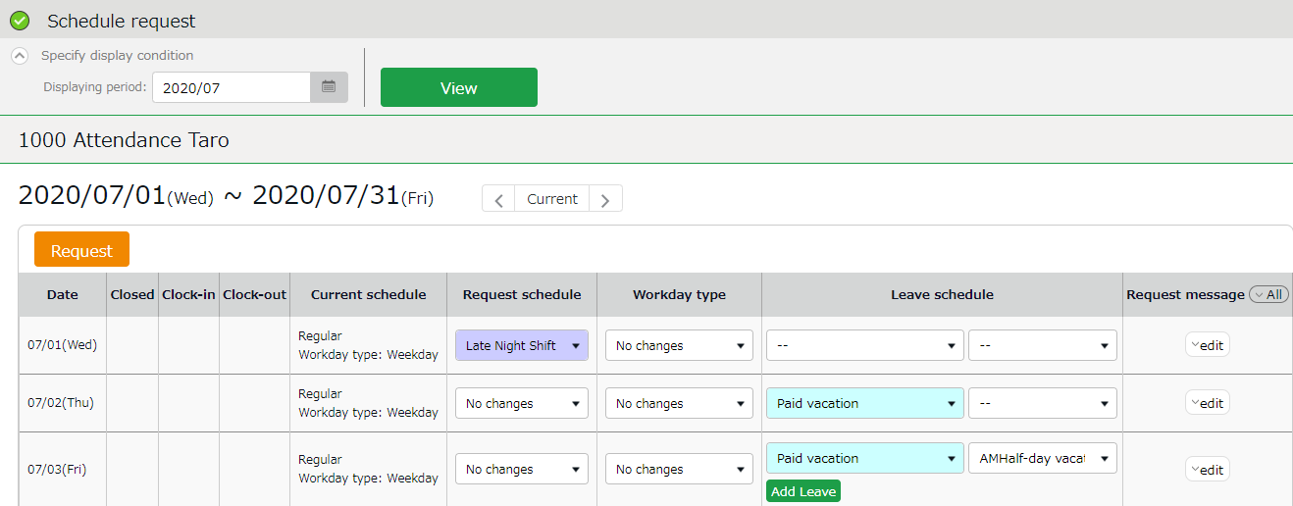
1ｚ
3
2ｚ

To edit schedule
Select a Schedule pattern for intended day.
Press the [Edit] button at [Request message] to enter the reason of request, etc.
Enter your message and submit.

To take full-day leave
To take leave, specify the leave type first, then select [All-day vacation] under [Leave schedule]. As an alternative, you can also use a leave pattern at [Request schedule] if there is one.

Edit schedule and take leave (Detailed request)
Submit schedule edit requests or leave requests. This section describes the steps to submit a detailed Schedule request for a single day.
Go to the Time Card screen and click [ Ξ ] in the Request column of the corresponding date. Then click [Schedule request].
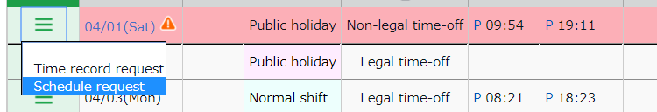

2.8.1. Description

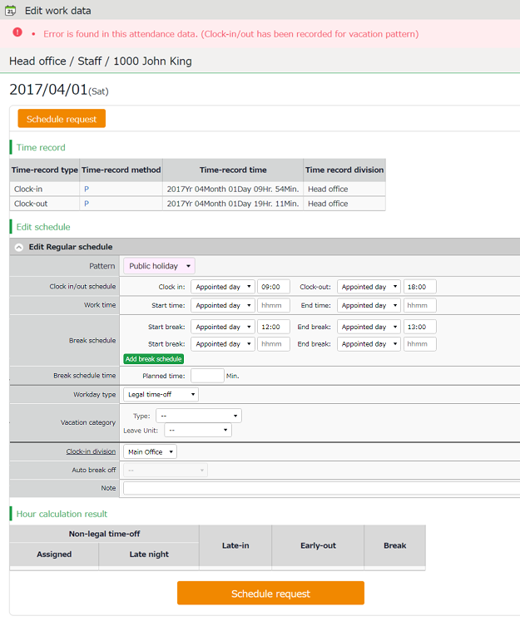
Schedule request

Submit change request from here.

Shows the time record data.
Time record data
Edit schedule

Edit your schedule here. Please refer to the following pages for details on each item.

Items at the Schedule Edit Screen
Pattern | By selecting a pattern, the time set to the schedule pattern is applied to the schedule.  You can also enter the items manually.
Clock-in/out schedule | This sets the clock-in/out schedule.
Work time | Working time within this time range will be calculated.  Any work before scheduled clock-in time and after clock-out time will not be included in the calculation.
Break schedule | The time between [Start break] and [End break] are regarded as break time.  Press the [Add break schedule] button to add new fields.
Break schedule time | The specified time will be calculated as break time, automatically.
Workday type | Determines whether the work took place during holiday or not.  You can choose from 3 workday types: [Weekday], [Legal time off], and [Non-legal time off].
Vacation category | When taking leave, select its type (e.g., paid leave, comp leave, etc.) and the unit (e.g., full-day leave, AM half-day leave, PM half-day leave, time, etc.).
Clock-in division | Shows where the employee clocked in.  The system automatically applies the name of the division time recorder last used.
Auto break off | Submit a request if you could not take break at the scheduled time.
Request message | Enter the reason of request.  Your administrator will read this message when checking your request.

2.8.2. To Submit Request
Enter the items required and press [Schedule request].
You can submit detailed schedules from here.

To submit overtime requests
You can submit overtime requests as follows.
Go to the Time Card screen and click [ Ξ ] in the Request column of the corresponding date. Then click [Overtime request].
* [Overtime request] is hidden if no schedule is set.
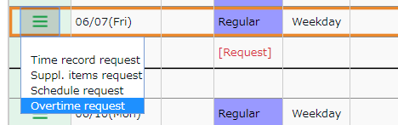

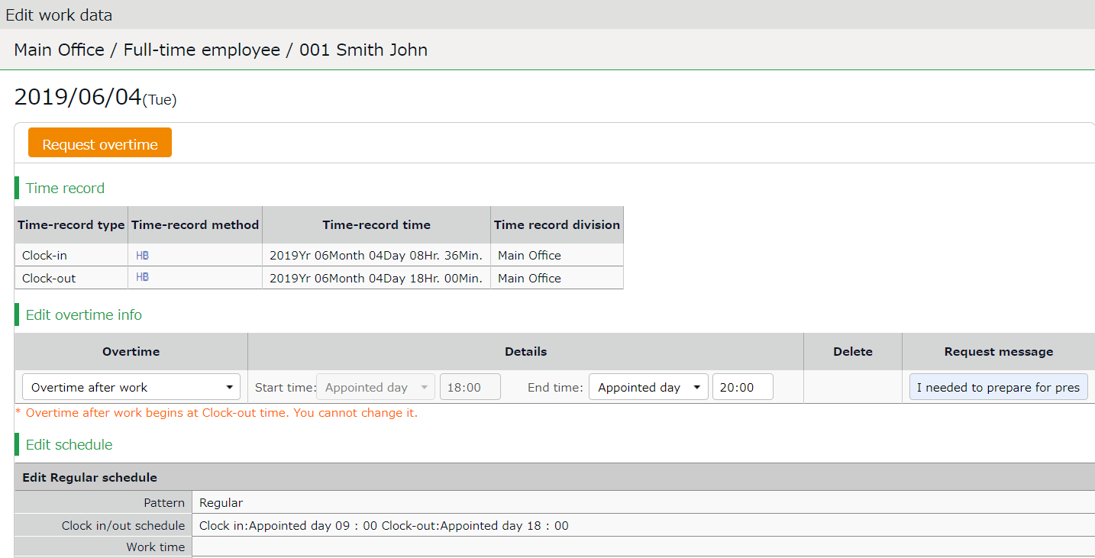
2.9.1. Description

Submit change request from here.
Overtime request

Time record data
Shows the time record data.

Shows the time record data.

First, check your regular clock-in/out schedule to decide between Overtime before work or Overtime after work. Please refer to the following pages for details on each item.

Edit overtime info

Overtime request
Enter Clock-in/out schedule and details of the request.
Request overtime before schedule | Enter the time before the Clock-in schedule.  *The End time field is disabled since it should be the same as the scheduled Clock-in time.
Request overtime after schedule | Enter the time after the Clock-out schedule.  *The Start time field is disabled since it should be the same as the scheduled Clock-out time.
Delete | Turn the check box on to request deletion.
Request message | Enter the reason of request.  Your administrator will read this message when checking your request.

2.9.2. To Submit Request
This section describes steps to submit requests.
- At Overtime request, select [Request overtime before schedule] or [Request overtime after schedule].
To submit request for overtime before work hours, select [Request overtime before schedule].
To submit request for overtime after work hours, select [Request overtime after schedule].
* Since there is no [Add item] button in this feature, you need to send separate requests for overtime before and after scheduled work hours.
- Enter start and end time.
- Enter the request message and press [Request].

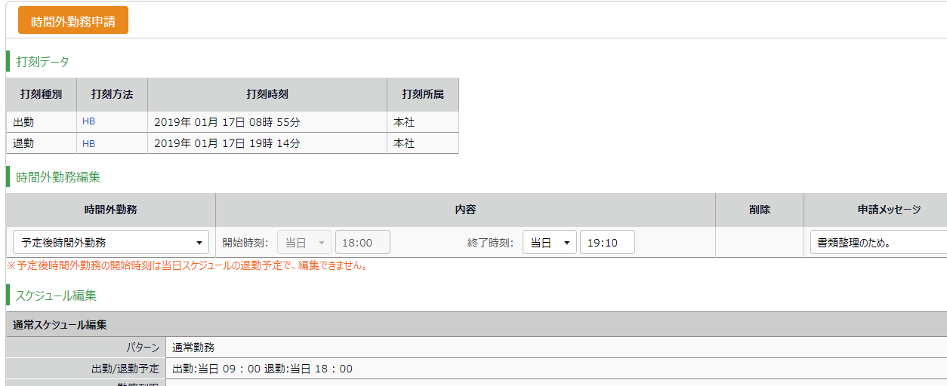

3
1ｚ
2

Example of a Schedule Pattern:
Clock-in 9:00 AM - Clock-out PM
An employee has worked from 7:00 AM and wants to submit an overtime request.
-> Select [Request overtime before schedule] and enter [7:00] in the Start time field.
Enter Request message, then click [Request].

An employee has worked until 8:00 PM and wants to submit an overtime request.
-> Select [Request overtime after schedule] and enter [20:00] in the End time field.
Enter Request message, then click [Request].

Check for schedule patterns that I can use
You can check the schedule patterns available to you.

[Where to look] All menu > Schedule > Available schedule pattern

The screen shows the schedule patterns set by your administrator.

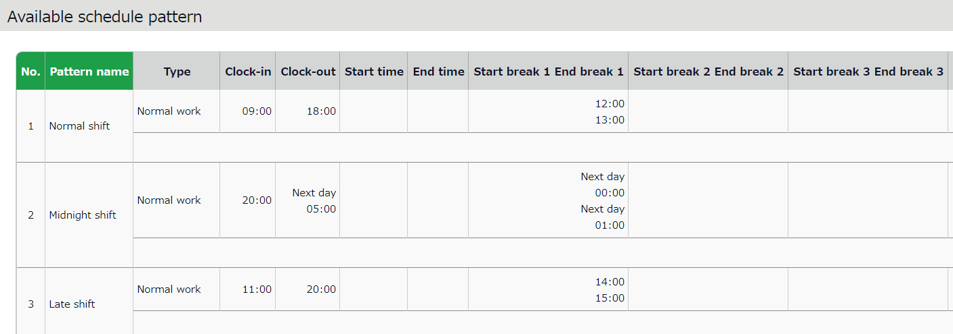
* This screenshot is a sample.

Confirm request log / Cancel requests
You can check requests that you have submitted during the past 60 days.
Requests that have not been approved yet can be canceled, by pressing the [Cancel submission] button.

[Where to look] All menu > Others > Request log (60 days)

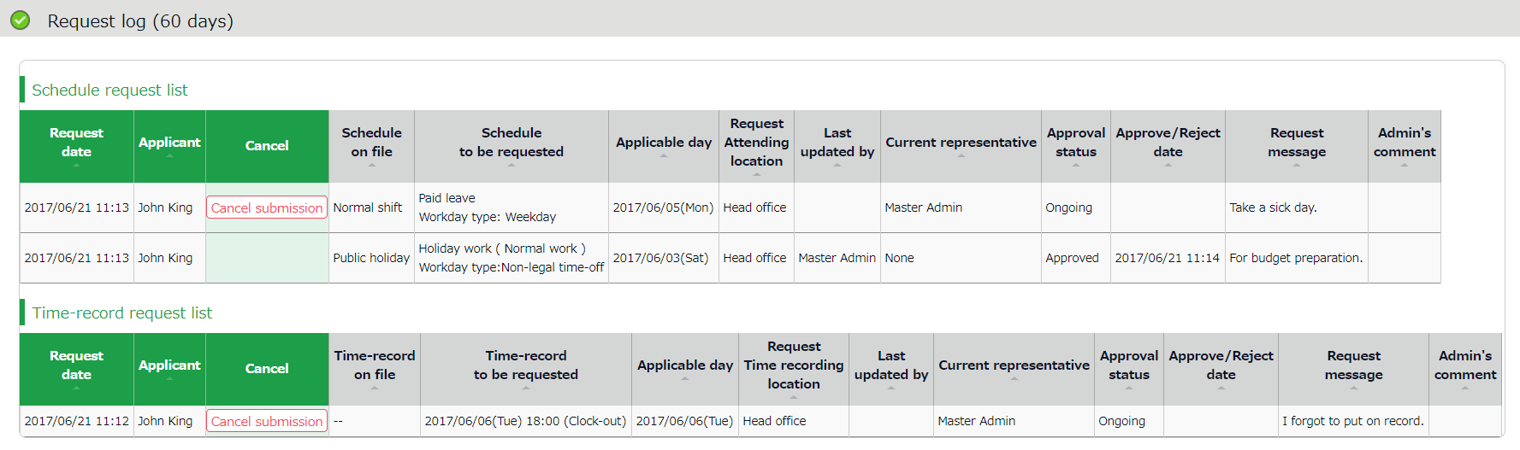

Change password
Change your password from here.

[Where to look] All menu > Others > Change password

2.12.1. To change password
- Enter your current password in the Password change screen. Then enter your new password.
- Press the [Change Password] button.
The next time you log in, use the new password.

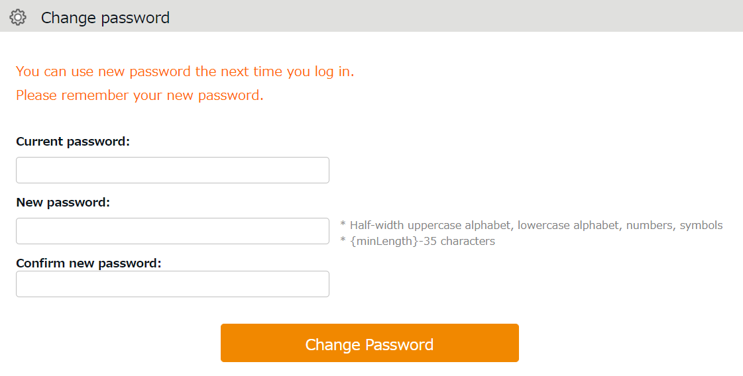

You need your password for the following purposes.
- Log into Employee screen
- To clock-in/out by password authentication

If you forgot your password, please contact your administrator to have your password reset.

Using Time Card on Mobile Browser
You can check your attendances, schedules, submit requests and change password from mobile phones or smart phones.

Supported browsers
The following browsers support Time Card.
Please use the latest version.

Mobile phones  Mobile Safari  iOS | Google Chrome for Mobile  Android | Default browsers*

* Not tested on on all devices.

Log into Time Card
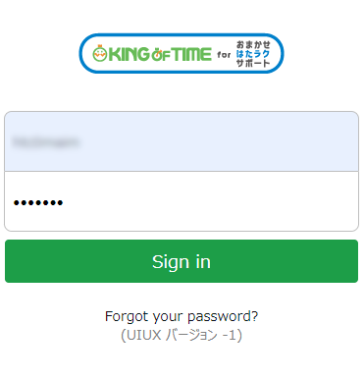
There are 2 ways to access the Time Card screen; by entering your ID, and by using the Time Recorder.

Login with ID
Start your browser and enter the Login URL in the address bar. Enter your login ID, password, then click [Login].
* The login ID and password are the same as those of PC browser version. * Please use the ID issued by your administrator and use the password you have set.
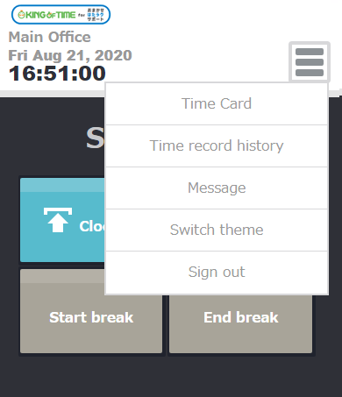

Log in from Time Recorder
Access the Mobile browser Time Recorder (or My Recorder) screen and press [Time Card].

All menu
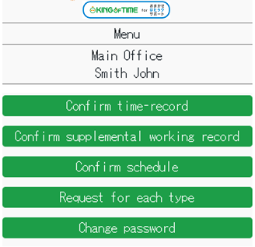

1ｚ

2ｚ
3ｚ

4ｚ

5ｚ

1 | Confirm time-record | Shows the time record data. | p.25
2 | Confirm Supplemental items | Shows Supplemental items data. | p.25
3 | Confirm schedule | Shows the current schedule. | p.26
4 | Request for each type | Submit requests from here. | p.27
5 | Change password | Change your password from here.  Enter your current and new password, then tap [Change password]. | -

Confirm Time Record/Supplemental Items
Tap [Confirm time-record] in Menu. To check Supplemental Items, tap [Confirm supplemental working record].
Light red indicates Attendance data error.

Confirm Supplemental items

Confirm time-record
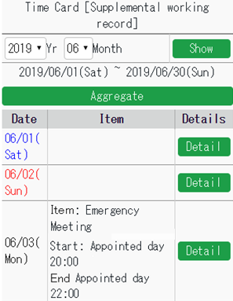
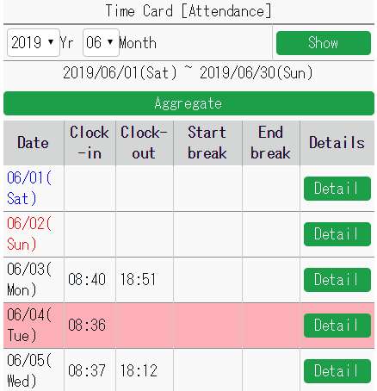
1ｚ
1ｚ

2ｚ
2ｚ

3ｚ
3ｚ

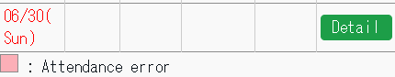
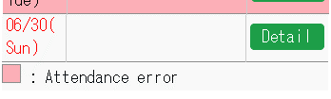

1 | Select Year and Month, then click [Display].
2 | You can check calculation results by pressing the [Aggregate] button.
3 | To check daily time record, schedules and other info, press [Detail].

Confirm schedule
To check your schedule, press [Confirm schedule] in Menu.
Light red indicates Attendance data error.

Confirm schedule
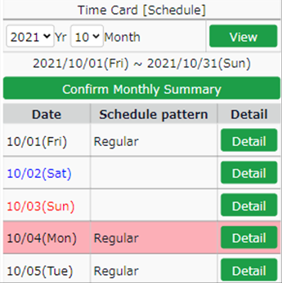
1ｚ

2ｚ

3ｚ

1 | Select Year and Month, then click [View].
2 | You can check calculation results by pressing the [Confirm Monthly Summary] button.
3 | To check daily time record, schedule and other info, tap [Details].

Submit Various Requests
Submit various requests.
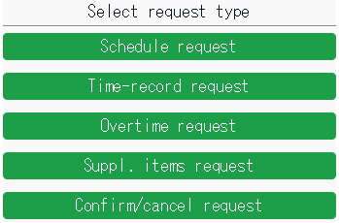

3.6.1. Schedule Request
Submit shift changes and leave requests from here.
- Tap [Request for each type], then [Schedule request].
Select a date from the calendar. You can also choose the date from [Target request date], then tapping [Select].
- Select a schedule pattern at [Request schedule].
To take leave, select [Full day leave] or [Half day leave]. If you have not taken any break, select [Auto break off]. Enter the [Request message], then tap [Submit].
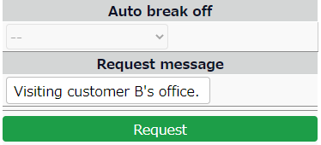
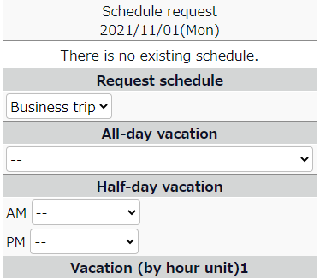
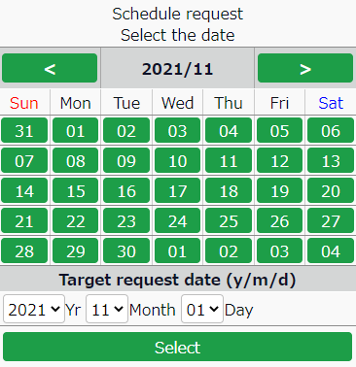

* If there are any unapproved schedule under the same date, you cannot submit another.
You can send new schedule requests only after your manager approves the previous request.
To confirm or cancel requests……………p.32

3.6.2. Time record request
You can submit time record requests in case you forgot to clock-in/out.
- Tap [Request for each type], then [Time record request].
Select a date from the calendar. You can also choose the date from [Target request date], then tapping [Select].
- Press the buttons accordingly.
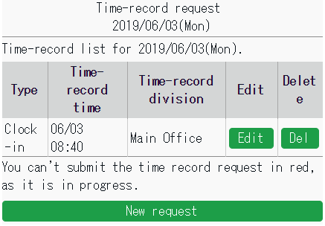

[Edit] | Submit a request to edit the existing time record.
[Del] | Submit request to delete the existing time record.
[New request] | To add a new time record data, submit a request from here.

- Enter the Time-record type, Time, Request message then tap [Request].
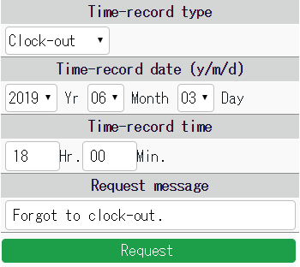

3.6.3. Overtime Request
If you have worked before or beyond normal working schedule, you can submit overtime requests as follows.
This is useful for reporting early-ins and overtime work.
By performing the following steps, the system counts overtime as working hours.

- Tap [Request for each type], then [Overtime request].
- Tap either [Request overtime before schedule] or [Request overtime after schedule].
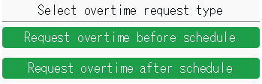

- Select a date from the calendar.
You can also choose the date from [Target request date], then tapping [Select].

Calendar Select year and month
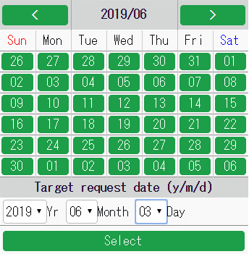
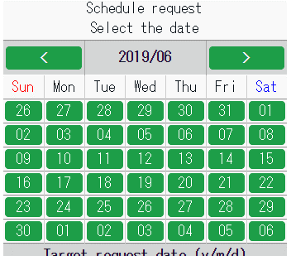

- Enter [Start time] and [End time].
If you are requesting overtime before schedule, enter [Start time].
If you are requesting overtime after schedule, enter [End time].
Enter the [Request message], then tap [Submit].
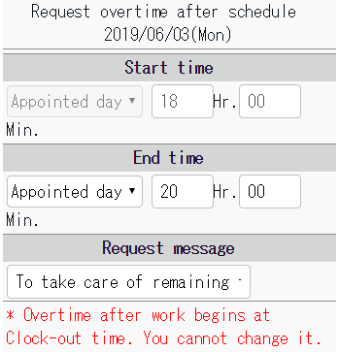
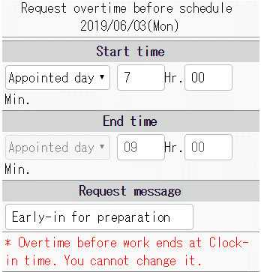

3.6.4. Submit Supplemental Item Info
Submit Supplemental item info as follows.
1. Tap [Request for each type], then [Suppl. items request].
2. Select a date from the calendar. You can also choose the date from [Target request date], then tapping [Select].
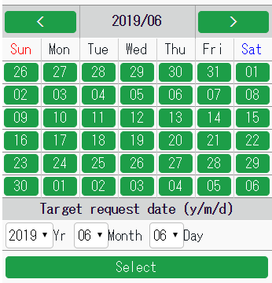
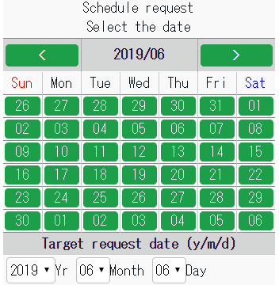
Calendar Select year and month

3. Press the buttons accordingly.
New request Screen with existing data
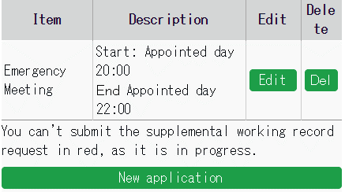
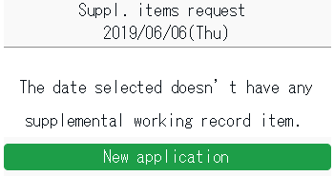

[Edit] | Submit a request to edit the existing time record.
[Del] | Submit request to delete the existing time record.
[New request] | To add a new time record data, submit a request from here.

New registration
・After selecting a date, tap [New request].
(The number of items shown depends on settings by your admin.)

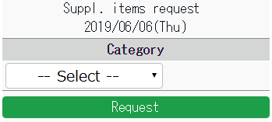

・Input method varies by the item selected.
Enter the items as required before submitting.
Time Span
Value
Dropdown

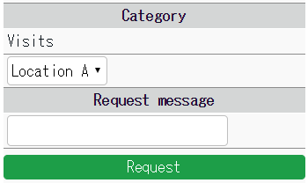
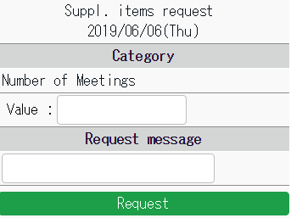
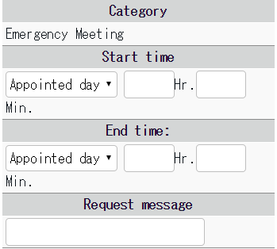

3.6.5. Confirm attendance data
Perform the following steps to confirm your attendance data.

1. Tap on [Confirm time-record] or [Confirm schedule].  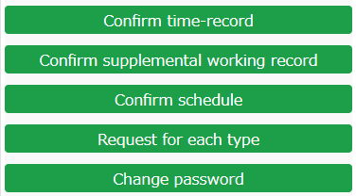  3. Scroll to the bottom of the screen and tap the [Confirm Attendance Data] button.  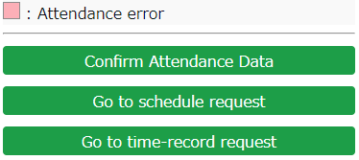 | 2. Specify the year and month, then tap the [Show] button.  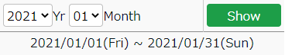  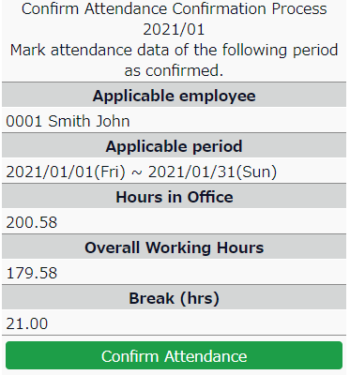  4. Check the details and tap the [Confirm Attendance] button.

3.6.6. Confirm or cancel request
Confirm or cancel request.
Tap [Request for each type], then [Confirm/cancel request].
Here, you can confirm or cancel your requests.
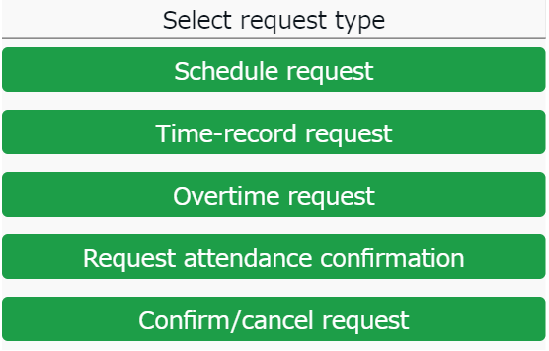
* You can check requests submitted during the past 60 days.
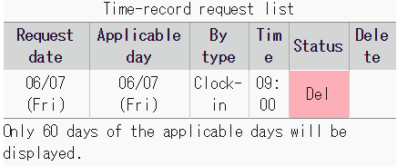
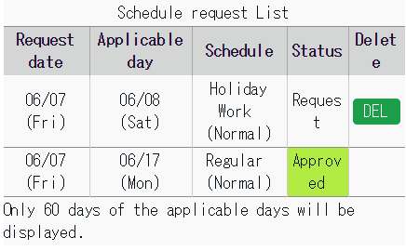

Request | This request has not been approved yet.  You can cancel the request by tapping the [DEL] button on the screen.
Approved | The request has been approved.
Del (Reject) | The request has been rejected.

My Recorder
This section describes how to clock in/out on My Recorder.

My Recorder
My Recorder is a personal Time Recorder that you can access from your smartphone, tablet or PC browser. It can record time and location info.
*To use My Recorder, your administrator needs to send you the My Recorder URL and ID.
Please use your password to login.
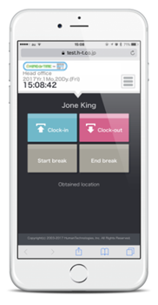
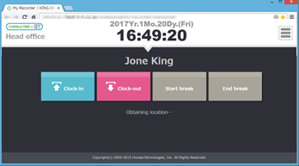

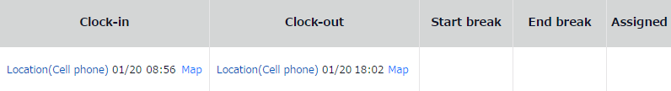

Supported devices and browsers
The following browsers support My Recorder. Please use the latest version. My Recorder is not available on feature phones (mobile phones).
Device | Browser
Windows PC | Google Chrome / Microsoft Edge
Mac | Google Chrome / Microsoft Edge
Android smart phone | Google Chrome for Mobile
iOS (iPhone, iPad) | Mobile Safari
*2 Microsoft Edge must be chromium-based, versions 79.0.309.713 and later.
Earlier versions are not recommended.
* The Location info feature is only available on devices with GPS function.

To access My Recorder
- Access the Time Recorder URL by following the instructions on the [Notice about Time Recorder URL/My Recorder URL] Email, sent from your administrator.
* The sender of the Email is no_reply@kt.hataraku-ntt-east.jp

- ID/password entry screen is initially displayed.
Enter your login ID and the password you have set, then click [OK].
If the authentication succeeds, Time Card is displayed.
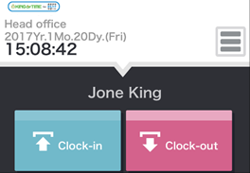
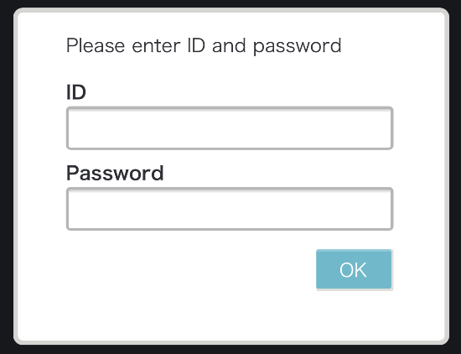

If the [Obtain location info] mode is turned on at the Admin screen, the screen may show a location permission message. Please permit.
* Messages may vary by browser and version.

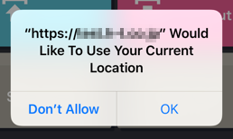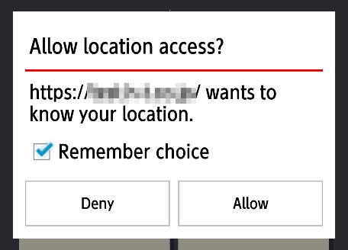
On Safari
On Google Chrome
Please bookmark the My Recorder URL and open it from the bookmark when you want to clock in/out.

Operate My Recorder
This section describes the steps to use My Recorder.

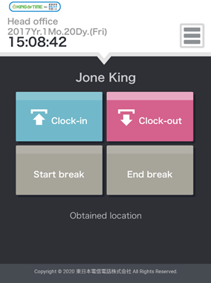
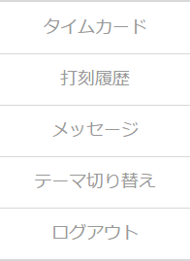
7
6
5
4
3

1ｚ

2

1 | Tap here to clock-in/out.  [Clock-in] [Clock-out]  [Start break] [End break]  * [Start break] [End break] buttons may or may not be displayed, depending on settings.
2 | Location info obtainment status is shown. (Available if the Obtain location info mode is turned on, in the Admin screen) Location info can be edited, if [Obtained location] is displayed.
3 | Displays Time Card. You can check attendances and submit requests from here.
4 | Shows the history of clock ins/outs recorded on the browser.  * You cannot check data recorded from other Time Recorders.
5 | Shows updates, maintenance info and messages from your administrator.
6 | 2 themes are available. Please choose the one you like.  Changes to theme only apply to the browser that you are using.
7 | Log out of My Recorder from here.  After logout, ID and password are required to re-login.

4.4.1. Clock-in/out
- Access My Recorder URL from your bookmark.
- Click [Clock-in].
If the clock-in succeeds, the screen shows the [Clock-in completed] message.
* Perform the same procedure to clock-out/start and end break.
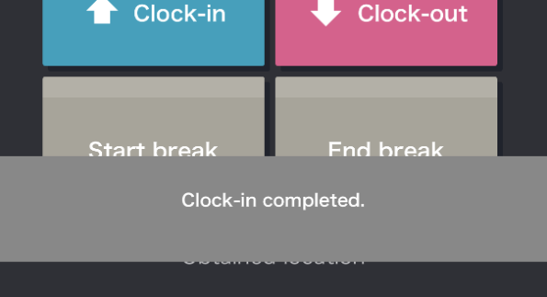

4.4.2. Check Time record history
To check time record log performed on the browser, click [Time record history] in the menu.
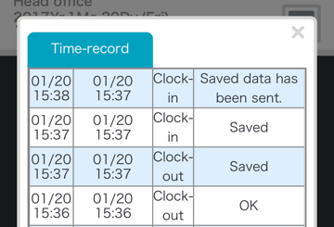
Status | Details
OK | Time record data has been submitted to the server successfully.
Save | Time record data has not been submitted. Instead, it has been temporarily saved on the device. This is displayed if the Time Recorder was off-line when the clock-in/out took place.
Saved data has been sent | Time record data temporarily saved on your device has been submitted to the server successfully.
* You cannot check edited data and data recorded from other Time Recorders.
If you clear your web browser's cache and cookies, Time record history are cleared as well.

4.4.3. Display Time Card
To access Time Card, press the [Time Card] button in All menu.
For instructions, please refer to the following pages.

To access Time Card on PC – p.4
With Mobile device - p.23

Mobile browser recorder
This section describes how to use the Mobile browser recorder.

What is a Mobile browser recorder?
A Mobile browser recorder is a time recorder that you can use on your mobile phone or smartphone.
Employees can clock-in/out by using personal Time Recorders. The URL is issued to each employee. It can record time and location info.
* To use it, your administrator needs to issue a Time Recorder URL.
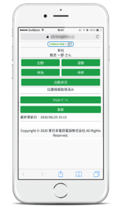
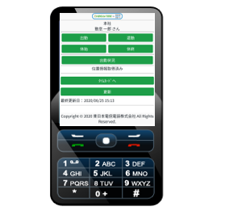

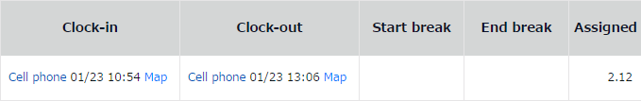

Supported models and mobile carriers
The following devices and environment support Mobile browser recorder.

Device | Mobile carrier/OS | Conditions required for Location info mode
Feature phones | docomo | Open area i-mode-compatible devices
 | au | Devices that support Location info by EZ Navi and  Device compatible with EZ Navi network types (device:gpsone)
 | SoftBank | Devices that support “location” scheme specified in “Action” attribute, under “form” element
Smart phones | Android | Browsers that support Geolocation API
 | iPhone | Browsers that support Geolocation API
* The Location info feature is only available to devices with GPS or cell location function.

To access Mobile browser recorder
This section describes how to go to the Time Recorder.

5.3.1. Check Email settings
Time Recorder URL Email notifications are sent by administrators from the Admin screen.
If you are using a Mobile phone, please check your Email settings beforehand.

Mobile carrier | To check Email settings (may not be applicable to some models)
docomo | iメニュー (i Menu) > お客様サポート (Customer Support) > 各種設定 (Settings) > メール設定 (E-mail settings) >  迷惑メール対策設定 (Spam Mail Prevention) > 詳細設定 (Detailed settings) > URL付きメール拒否設定 (Reject mail with URL) > [設定解除 (Undo settings)]
au | E-mail button > Eメール設定 (E-mail Setup) > メールフィルター (Filter Settings) > 個別設定 (Individual Settings) >  その他の設定 (Other Settings) > URLリンク規制 (URL link restriction) > [規制しない (Do not restrict)]
SoftBank | E-mail button > 設定 (Mail setting) > メール・アドレス設定 (Address setting) > Enter security code >  迷惑メールブロック設定 (Spam mail settings) > [個別に設定 (Individual settings)]  URLリンク付きメール拒否設定 (Block E-mails with URL link) > [全て受け取る (Receive all)]

* Setup method may vary by software versions released from the mobile carrier.
Display format may also vary by device models.

5.3.2. To access
Access the Time Recorder URL by following the instructions on the [Notice about Time Recorder URL/My Recorder URL] Email, sent from your administrator.
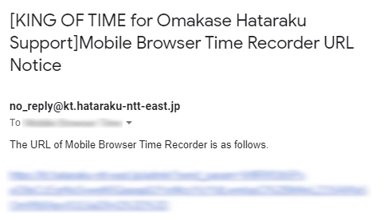
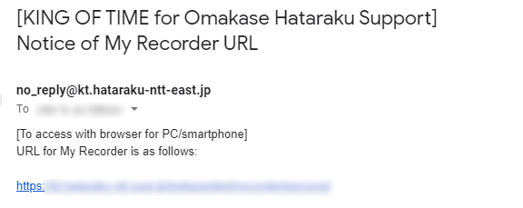
The sender of the Email is [no_reply@kt.hataraku-ntt-east.jp] (send-only address). You cannot reply to this Email.

If there is a line-break in the middle, please fix it to one line before entering it into the address bar.

For easier access, bookmark the Time Recorder URL.

(If you use the Screen Memo function instead of bookmarking the URL, some features may not function correctly when updated.)

Operating the Mobile browser recorder
This section describes the steps to use Mobile browser recorder.

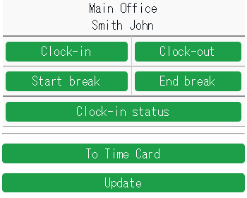
6
1ｚ
2
5
4
3

1 | Shows your name and division.
2 | Tap here to clock-in/out.  [Clock-in] [Clock-out]  [Start break] [End break]  * [Start break] [End break] buttons may or may not be displayed, depending on settings.
3 | Shows present or past time record data.  * You cannot check data that were recorded from other Mobile browser recorders.
4 | Location info obtainment status is shown. (Available if the Obtain location info mode is turned on, in the Admin screen) Location info can be edited, if [Obtained location] is displayed.
5 | Displays Time Card.
6 | Reloads browser.

5.4.1. Clock-in/out
Go to Time Recorder URL from your bookmark.
Tap [Clock-in]. Confirmation screen is displayed if clock-in succeeds.
* Perform the same procedure to clock-out/start and end break.
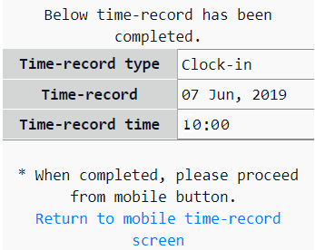
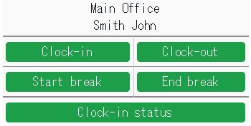

5.4.2. Check attendance status
You can check time record data by each day.

1. Tap [Clock-in status].
2. Select a date and tap [Display].
3. To return to the Time Recorder screen, select [9] Update.

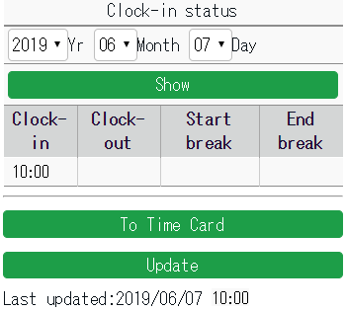

5.4.3. To Check Time Card
To check your Time Card, select [0] Time Card.
For detailed instruction, please refer to p.23.

FAQ

I forgot my login info.
If you have forgotten your ID or password,
please contact your administrator. The administrator can check your ID and re-issue your password.

I submitted the wrong request.
You can cancel requests if they have not been approved yet.
Please cancel the wrong request, then submit the correct one. If the request has already been approved, please submit a new request. Make sure the same request date is set. You can submit requests on the same date as many times as you need unless your administrator has closed the attendance data.

I somehow got logged out when I accessed the My Recorder URL. What happened?
You may have cleared your web browser's cache and cookies, causing it to log out from My Recorder. Please enter your login ID and password again.

[Admin] How do I send My Recorder URL?
First, log into the Admin screen. Go to [Home page > Settings > Employee > Employee settings].
Press [Send Email] to send.
If My Recorder Email template is not available, please contact the support center to add the function.
When using My Recorder, please check the version of your browser.

Unauthorized copying and replication of the contents of this guide, text and images are strictly prohibited.
The contents of this guide are subject to change without prior notice, for revision and further improvement.

Last Updated – March 13, 2022

